

American International University-Bangladesh (AIUB)
Department of Computer Science
Faculty of Science & Technology (FST)

Pharma Track—Pharmacy Stock and Sales Management System [PSSMS]

Semester: Fall 25-26
Group: 05 (Turtlers) |  | Section: Q
SL | Student Name | Student ID
1 | SHOHAG RANA | 23-54897-3
2 | Borshon Debnath | 23-55078-3
3 | Anurag Sarkar | 23-55049-3
4 | MARUF AHAMMED | 23-54391-3

Table of Contents

1.1 INTRODUCTION 3
1.1.1 Selection of Process Model: 5
2. SCOPES & FEATURES 6
2.2 Scope 1: Profile Management 6
2.3 Scope 2: User Management (Admin Only) 6
2.4 Scope 3: Inventory Management 6
2.5 Scope 4: Sales and Billing Management 6
2.6 Scope 5: Reporting and Dashboard 7
2.7 Scope 6: Supplier Management 7
2.3.USER STORY TABLE 8
2.8 Functional Requirements 10
2.8.1 Admin Requirements: 10
2.8.2 Pharmacist Requirements: 11
2.8.3 Cashier Requirements: 12
2.8.4 Supplier Requirements: 12
2.8.5 Customer Requirements: 13
2.9.Non Functional Requerments 15

3. SOFTWARE DESIGN e16
3.2. Class Diagram 17
3.2 UI / Wireframe Design using Figma 18
1.1.2 3.2.2. Signup page 18
4.1. GIT WORKFLOW 21
4.2.Clone Git Workflow: 26
5. SOFTWARE TESTING 29
6. CONCLUSION 33

INTRODUCTION
1.2. Background Problem:
At present, most of the pharmacies are being organized by maintaining old traditional rules. Most of the pharmacy stake holders are dependent on pen-paper for recording, paper’s file for tracking. Phone calls are the main method for contacting suppliers and customers. These types of manual activities slow down pharmacies’ daily activities. When any important information needed, it’s very hard to find, even sometimes, might not be found. Errors in billing, stock counting, record keeping are much familiar for these types of pharmacies. On the other hand, stakeholders expect a faster, reliable, easy-to-understand system. Traditional management cannot meet the needs of the modern digital pharmacy era.
In the present much-advanced digital era, the pharmaceutical industry should not lag behind. Pharmacy management has become quite an essential element for maintaining smooth operations and ensuring the delivery of quality health care services. Many small- and medium-sized pharmacies still rely heavily on manual systems, which quite often lead to mismanagement in their operations. Frequent errors such as stockouts, overstocking, and incorrect sales tracking reduce overall profitability. More importantly, these issues may compromise patient safety when critical or lifesaving medications are unavailable at the right time.
A pharmacy nowadays has to coordinate with several suppliers, accurately track batches, and monitor the expiration dates of drugs while being compliant with regulatory standards. These are all time-consuming activities if managed manually and prone to human error. Consequently, there is an increasing demand for a contemporary, integrated, automated system that would take care of such complicated processes.
Pharma Track - Pharmacy Stock and Sales Management System [PSSMS], a digital pharmacy management system, is designed to meet these challenges. It is an overall digital solution that equips pharmacies with effective tools for inventory management, real-time sales tracking, and expiration deadline tracking.
It will help the pharmacy to improve operational efficiency, remain compliant, and ultimately offer better healthcare services to customers and patients alike.
Key benefits of Pharma Track-PSSMS:
- Improved accuracy in inventory management
- Real-time sales tracking and data-driven insights
- Tracking upcoming expiries automatically with timely notifications
- Reduction in human errors and workflow bottlenecks
- Improved Compliance with Pharmaceutical Standards
Ultimately, Pharma Track-PSSMS will enhance the operational effectiveness of pharmacies, reduce financial losses, and ensure a constant supply of key medicines. It is high time to forget old traditional systems and rely on digital pharmacy management like PSSMS. A system like this can enhance pharmacy management in modern era.
Target Group of Users:
The Pharma Track-PSSMS summarizes information from all activities transacted within the system into useful insights. While the admin drives this reporting aspect of the use case, the information is supported by contributions provided by the five key identified user groups. This ensures that every operational action, every action related to inventory, sales, billing, and delivery, is indeed reflected in those final reports.
The reporting module becomes powerful because each of the five targeted users contributes essential data. The five targeted users of Pharma Track - Pharmacy Stock and Sales Management System [PSSMS] are:
- Admin: Admin is the head user here in PSSMS. He can control and check accuracy of each user. Admin will generate and review comprehensive reports, which include sales summaries, inventory status, listings for expiry, performance of suppliers, financial logs, and reports on user activities. Admin can update their details, track and sack other users.

- Pharmacist: Pharmacists have the second highest priority among the users of PSSMS. He will be appointed by admin. Pharmacists will provide the critical data through medicine updates, expiry monitoring, stock checks, and sales entries, which form the basis of inventory and expiry-related reports.

- Cashier: The main responsibility of cashier is to make up-to-date financial matters. Cashiers will provide critical data through medicine updates, expiry monitoring, stock checks, and sales entries, which form the basis of inventory and expiry-related reports. Even if some products are being imported or exported, he will be responsible for updating the financial calculation.

- Supplier: Suppliers know better about invoices and pricing. It will also ensure transparency. Suppliers will add delivery update information, batch numbers, invoices, and pricing information to contribute to the procurement and supply chain reports.

- Customer: Customers will be field-level users of PSSMS. They will be able to order inventory, check prices, expiration date, availability in stock, batch numbers and other info about pharmaceutical elements. They don’t need to come to pharmacy to know about these, they will be able to know from home if they use PSSMS.

These are the five targeted users of PSSMS. It ensures completeness and reliability in the reporting system by integrating the various contributions from the five users. This smooth flow of information within the system improves accuracy, enhances transparency, and supports better decision-making across the pharmacy. At the end, the Generate Reports feature strengthens operational control and accountability and helps to maintain a well-organized and compliant pharmacy management environment.

Selection of Process Model:
The Pharma Track – Pharmacy Stock and Sales Management System (PSSMS) is a structured system with clearly identified functionalities, user roles, and operational workflows. Due to these characteristics, the Waterfall model is an appropriate and effective development approach for this project.
The reasons for selecting the Waterfall model are explained below:
- Clear and Well-Defined Requirements
The requirements of PSSMS—such as inventory management, sales tracking, expiry monitoring, billing, supplier handling, and reporting—are already well understood. Since pharmacy operations follow fixed business rules and regulatory standards, the Waterfall model fits well as it emphasizes thorough requirement analysis at the beginning.
- Structured User Roles and Responsibilities
The system has five clearly defined user groups: Admin, Pharmacist, Cashier, Supplier, and Customer. Each role has specific responsibilities that can be analyzed and documented early, allowing smooth progression through design and development phases without frequent requirement changes.
- Regulatory and Compliance Needs
Pharmacy systems must comply with pharmaceutical standards and record-keeping regulations. The Waterfall model ensures strong documentation at every stage, which is essential for audit trails, compliance verification, and future maintenance.
- Stable System with Limited Future Changes
Core pharmacy operations such as stock control, sales recording, and reporting do not change frequently. Therefore, a model like Waterfall, which is less flexible to late-stage changes, is still effective and efficient for this project.
- Suitable for Documentation-Driven Projects
As this project requires detailed documentation (SRS, design diagrams, reports), the Waterfall model supports strong documentation practices, which are essential for understanding, evaluation, and future enhancement.

Waterfall Process Model is a suitable choice for developing the Pharma Stock and Sales Management System (PSSMS) due to its structured approach, clear requirement handling, strong documentation support, and suitability for stable and compliance-driven systems. By following the Waterfall model, the project can be developed systematically, ensuring accuracy, reliability, and compliance while delivering a robust digital solution for modern pharmacy management.

SCOPES & FEATURES

Scope 1: Profile Management
Features:
- Store officers and customers can create new profiles with valid information.
- All users can log in with a valid username and password.
- After successful login, all users can view their dashboard.
- All users can view their own profile details.
- All users can update their information with valid information.
- All users can change their password.
- All users can recover their password after verification.

Scope 2: User Management (Admin Only)
Features:
- Admin can add new users (pharmacist, cashier, supplier).
- Admin can update user information.
- Admin can delete users from the system.
- Admin can assign roles and permissions to users.

Scope 3: Inventory Management
Features:
- Pharmacists can add new medicines with batch numbers, expiry dates, and pricing.
- Pharmacists can update existing medicine details.
- Admin can approve stock updates from pharmacists.
- Users can check stock availability.
- System can generate alerts for low stock and upcoming expiry dates.

Scope 4: Sales and Billing Management
Features:
- Cashiers can create bills and add items.
- Cashier can generate invoices for customers.
- Cashier can record payments.
- Cashier can submit daily sales reports.
- System can validate sales amounts automatically.

Scope 5: Reporting and Dashboard
Features:
- Admin can view a dashboard with summarized reports.
- Reports include sales summaries, inventory status, expiries, supplier performance, and financial logs.
- Admin can generate printable/downloadable reports.
- Reports integrate data from all user actions for accuracy.

Scope 6: Supplier Management
Features:
- Suppliers can update the delivery status of medicines.
- Suppliers can provide invoices and add batch numbers.
- Suppliers can respond to stock requests from pharmacies.
- Suppliers can update product pricing. e) Supplier can negotiate prices when extending stock supply.

2.3.USER STORY TABLE
As A/An | I want to | So that | Acceptance Criteria
Customer | Create an account | I can enroll myself in the system | Valid data saves and confirmation is sent
 | Login with username and password | System can authenticate me | After login, dashboard loads
 | View my profile details | I can see all my information | Profile table visible with edit option
 | Update my information | I can correct wrong information | Updated info saved and displayed
 | Change my password | My account becomes secure | Old & new password required; success message shown
 | Recover my password | I do not lose access if I forget it | OTP sent and reset allowed
 | View available medicines | I can check products before visiting | List of available medicines shown
 | View past invoices | I can track purchases | Invoice history list displayed
As A/An | I want to | So that | Acceptance Criteria
Pharmacist | Add new medicine | Newly released medicine can be added | Fields required; success message
 | Search for medicine | I can check quantity | List of matching medicines displayed
 | Update medicine information | Everyone has updated information | Updated medicine list shown
 | Remove medicine | Medicine no longer appears | Medicine removed and list updated
 | View medicine list | I see updated quantities | Updated list with delete/update options
 | Send stock request | I can restock medicines | Request successfully sent
As A/An | I want to | So that | Acceptance Criteria
Cashier | Create bills | I can process purchases | Bill generated with totals
 | Generate invoice | Customer gets receipt | Printable invoice created
 | Record payments | Transactions are stored | Payment logged with timestamp
 | Submit sales report | Admin can review profit | Report successfully submitted
 | View stock availability | I confirm items before billing | Stock list displayed
As A/An | I want to | So that | Acceptance Criteria
Supplier | Update delivery status | Pharmacy knows progress | Status updated and visible
 | Provide invoices | Documentation stays complete | Invoice uploaded and saved
 | Respond to stock requests | I confirm or deny orders | Response saved
 | Update pricing | Pharmacy sees correct prices | New price applied
 | Negotiate pricing | I offer flexible deals | Negotiation stored
As A/An | I want to | So that | Acceptance Criteria
Admin | Add new users | System has authorized users | User created with role
 | Update user information | Records stay correct | Changes saved
 | Delete users | Unauthorized access removed | User removed
 | Assign roles | Control access properly | Role permissions applied
 | View dashboard | Monitor all operations | Dashboard loads with analytics
 | Generate reports | Audit and analysis possible | Reports downloadable (PDF/Excel)
 | Approve stock updates | Inventory stays accurate | Approval logged in system

2.8 Requirements Traceability Matrix

Functional Requirements

Admin Requirements:
No | Requirement Description
1.0 | User Home Page – All features accessible
1.1 | Registration / Add New Users
1.1.1 | Enter new user details
1.1.2 | Assign roles [ref 1.1.1]
1.2 | Login
1.2.1 | Enter username
1.2.2 | Enter password
1.2.3 | Forgot password option
1.2.3.1 | Recover password
1.2.3.1.1 | Enter registered email/phone
1.2.3.1.2 | Send OTP/link for verification [ref 1.2.3.1.1]
1.2.4 | Submit login form [ref 1.2.1, 1.2.2]
1.3 | Dashboard
1.3.1 | View Admin Dashboard after login [ref 1.2.4]
1.4 | Profile Management
1.4.1 | View profile details [ref 1.3.1]
1.4.2 | Update profile
1.4.2.1 | Enter new contact/personal info
1.4.2.2 | Submit updated info [ref 1.4.2.1]
1.5 | Change Password
1.5.1 | Enter old password
1.5.2 | Enter new password
1.5.3 | Confirm new password
1.5.4 | Submit change password form [ref 1.5.1, 1.5.2, 1.5.3]
2.0 | User & System Management
2.1 | Update user information
2.2 | Delete users [ref 2.1]
2.3 | Assign roles & control access [ref 2.1]
2.4 | Approve stock updates [ref 2.1]
2.5 | Generate reports [ref 1.3.1]
2.6 | View dashboard analytics [ref 1.3.1]

Pharmacist Requirements:
1.0 | User home page – All features availability
1.1 | Login [ref Customer 1.2]
1.2 | Dashboard
1.2.1 | Side menu
1.2.1.1 | Dashboard button
1.2.1.2 | Add new medicine button
1.2.1.2.1 | Taking medicine name
1.2.1.2.2 | Taking manufacturer
1.2.1.2.3 | Taking price
1.2.1.2.4 | Taking quantity
1.2.1.2.5 | Submitting the form
1.2.1.2.6 | Showing success message
1.2.1.3 | Search medicine button
1.2.1.3.1 | Taking medicine name
1.2.1.3.2 | Submitting the form
1.2.1.3.3 | Showing matching medicine list
1.2.1.4 | Update medicine information
1.2.1.4.1 | Showing existing medicine details
1.2.1.4.2 | Taking updated name
1.2.1.4.3 | Taking updated price
1.2.1.4.4 | Taking updated quantity
1.2.1.4.5 | Submitting updated information
1.2.1.4.6 | Showing updated medicine list
1.2.1.5 | Remove medicine button
1.2.1.5.1 | Showing medicine details
1.2.1.5.2 | Confirming deletion
1.2.1.5.3 | Removing medicine
1.2.1.5.4 | Showing updated list
1.2.1.6 | View medicine list
1.2.1.6.1 | Showing full list of medicines
1.2.1.6.2 | Showing quantity, price, update & delete options
1.2.1.7 | Send stock request
1.2.1.7.1 | Taking item name
1.2.1.7.2 | Taking required quantity
1.2.1.7.3 | Submitting request
1.2.1.7.4 | Showing confirmation message
1.2.1.8 | Logout button

Cashier Requirements:
No | Requirement Description
1.0 | User Home Page – All features accessible
1.1 | Login
1.1.1 | Enter username
1.1.2 | Enter password
1.1.3 | Forgot password option
1.1.3.1 | Recover password
1.1.3.1.1 | Enter registered email/phone
1.1.3.1.2 | Send OTP/link for verification [ref 1.1.3.1.1]
1.1.4 | Submit login form [ref 1.1.1, 1.1.2]
1.2 | Dashboard
1.2.1 | View Cashier Dashboard after login [ref 1.1.4]
1.3 | Profile Management
1.3.1 | View profile details (Name, ID, Contact) [ref 1.2.1]
1.3.2 | Update profile
1.3.2.1 | Enter new contact/personal info
1.3.2.2 | Submit updated info [ref 1.3.2.1]
1.4 | Change Password
1.4.1 | Enter old password
1.4.2 | Enter new password
1.4.3 | Confirm new password
1.4.4 | Submit change password form [ref 1.4.1, 1.4.2, 1.4.3]
2.0 | Billing & Sales Operations
2.1 | Create bills [ref 1.2.1]
2.2 | Generate invoice [ref 2.1]
2.3 | Record payments [ref 2.1]
2.4 | Submit sales report [ref 2.1]
2.5 | View stock availability [ref 1.2.1]

Supplier Requirements:
No | Requirement Description
1.0 | User Home Page – All features accessible
1.1 | Login
1.1.1 | Enter username
1.1.2 | Enter password
1.1.3 | Forgot password option
1.1.3.1 | Recover password
1.1.3.1.1 | Enter registered email/phone
1.1.3.1.2 | Send OTP/link for verification [ref 1.1.3.1.1]
1.1.4 | Submit login form [ref 1.1.1, 1.1.2]
1.2 | Dashboard
1.2.1 | View Supplier Dashboard after login [ref 1.1.4]
2.0 | Delivery & Stock Operations
2.1 | Update delivery status [ref 1.2.1]
2.2 | Provide invoices [ref 2.1]
2.3 | Respond to stock requests [ref 2.1]
2.4 | Update pricing [ref 2.1]
2.5 | Negotiate pricing deals [ref 2.1]

Customer Requirements:
1.0 | User home page – All features availability
1.1 | Registration
1.1.1 | Taking name
1.1.2 | Taking email address
1.1.3 | Taking username
1.1.4 | Taking password
1.1.5 | Taking confirm password
1.1.6 | Taking gender
1.1.7 | Taking phone number
1.1.8 | Taking date of birth
1.1.9 | Taking address
1.1.10 | Taking postcode
1.1.11 | Taking city
1.1.12 | Taking division
1.1.13 | Submitting the registration form
1.1.14 | Resetting the form
1.1.15 | Showing successful registration confirmation
1.2 | Login
1.2.1 | Taking username
1.2.2 | Taking password
1.2.3 | Submitting login
1.2.4 | Showing dashboard after successful login
1.2.5 | Forgot password button
1.2.5.1 | Password recovery
1.2.5.1.1 | Taking registered contact/email
1.2.5.1.2 | Sending OTP
1.2.5.1.3 | Taking OTP
1.2.5.1.4 | Resetting password
1.2.5.1.5 | Showing success message
1.3 | Dashboard
1.3.1 | Side menu
1.3.1.1 | Dashboard button
1.3.1.2 | View profile button
1.3.1.2.1 | Show name
1.3.1.2.2 | Show email
1.3.1.2.3 | Show gender
1.3.1.2.4 | Show phone number
1.3.1.2.5 | Show date of birth
1.3.1.2.6 | Show address
1.3.1.2.7 | Show postcode
1.3.1.2.8 | Show city
1.3.1.2.9 | Show division
1.3.1.2.10 | Show profile picture
1.3.1.2.11 | Edit profile button
1.3.1.2.11.1 | Edit profile
1.3.1.2.11.1.1 | Show existing name and take updated name
1.3.1.2.11.1.2 | Show existing email and take updated email
1.3.1.2.11.1.3 | Show existing gender and take updated gender
1.3.1.2.11.1.4 | Show existing phone number and take updated phone number
1.3.1.2.11.1.5 | Show existing date of birth and take updated DOB
1.3.1.2.11.1.6 | Show existing address and take updated address
1.3.1.2.11.1.7 | Show existing postcode and take updated postcode
1.3.1.2.11.1.8 | Show existing city and take updated city
1.3.1.2.11.1.9 | Show existing division and take updated division
1.3.1.2.11.1.10 | Submitting updated information
1.3.1.2.11.1.11 | View profile
1.3.1.3 | Change password button
1.3.1.3.1 | Taking old password
1.3.1.3.2 | Taking new password
1.3.1.3.3 | Taking confirm new password
1.3.1.3.4 | Submitting the form
1.3.1.3.5 | Showing success message
1.3.1.4 | View available medicines
1.3.1.4.1 | Showing list of available medicines
1.3.1.4.2 | Showing name, price, and availability
1.3.1.5 | View past invoices
1.3.1.5.1 | Showing invoice history list
1.3.1.5.2 | Viewing invoice details
1.3.1.6 | Logout button
1.3.1.6.1 | Show login page
2.3.2 Non-Functional Requirements
1.Availability
The Pharma Track – Pharmacy Stock and Sales Management System (PSSMS) shall ensure high availability to support uninterrupted pharmacy operations.
* The system shall be available 24 hours a day, 7 days a week, except during scheduled maintenance periods.
* A minimum of 99% system uptime is required to guarantee uninterrupted access for administrators, pharmacists, cashiers, suppliers, and customers.

2. Manageability
The PSSMS shall be easy to manage, configure, and maintain by system administrators.
* An admin dashboard for managing users, roles, permissions, inventory approvals, and system reports will be provided by the system.
* Admins shall be able to add, update, suspend, or delete users without affecting system stability.
3.Usability
The system shall be user-friendly and easy to use for users with varying levels of technical knowledge.
* The user interface shall be simple, intuitive, and role-based, displaying only relevant features for each user type.
* Navigation menus, dashboards, and forms shall be clearly labeled and consistent across the system.

4. Performance
The PSSMS shall deliver fast and efficient performance to support real-time pharmacy operations.
* The system shall respond to user requests (login, search, billing, report generation) within 2–3 seconds under normal load.
* Inventory searches, stock availability checks, and medicine listings shall be processed in real time.

3. SOFTWARE DESIGN
3.1. USE CASE DIAGRAM
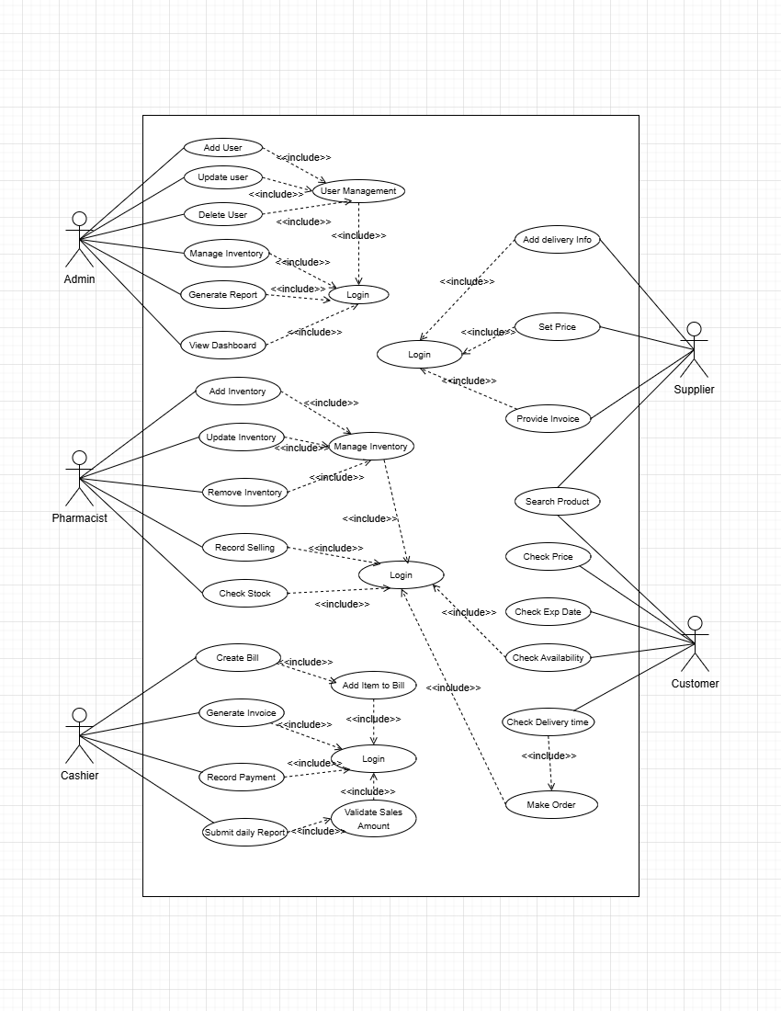

3.2. Class Diagram

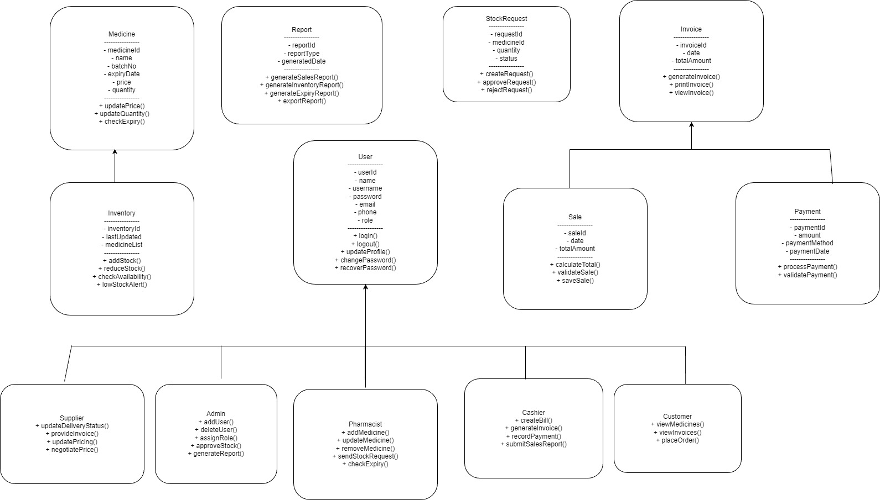

UI / Wireframe Design using Figma
3.2.1. Log in page :
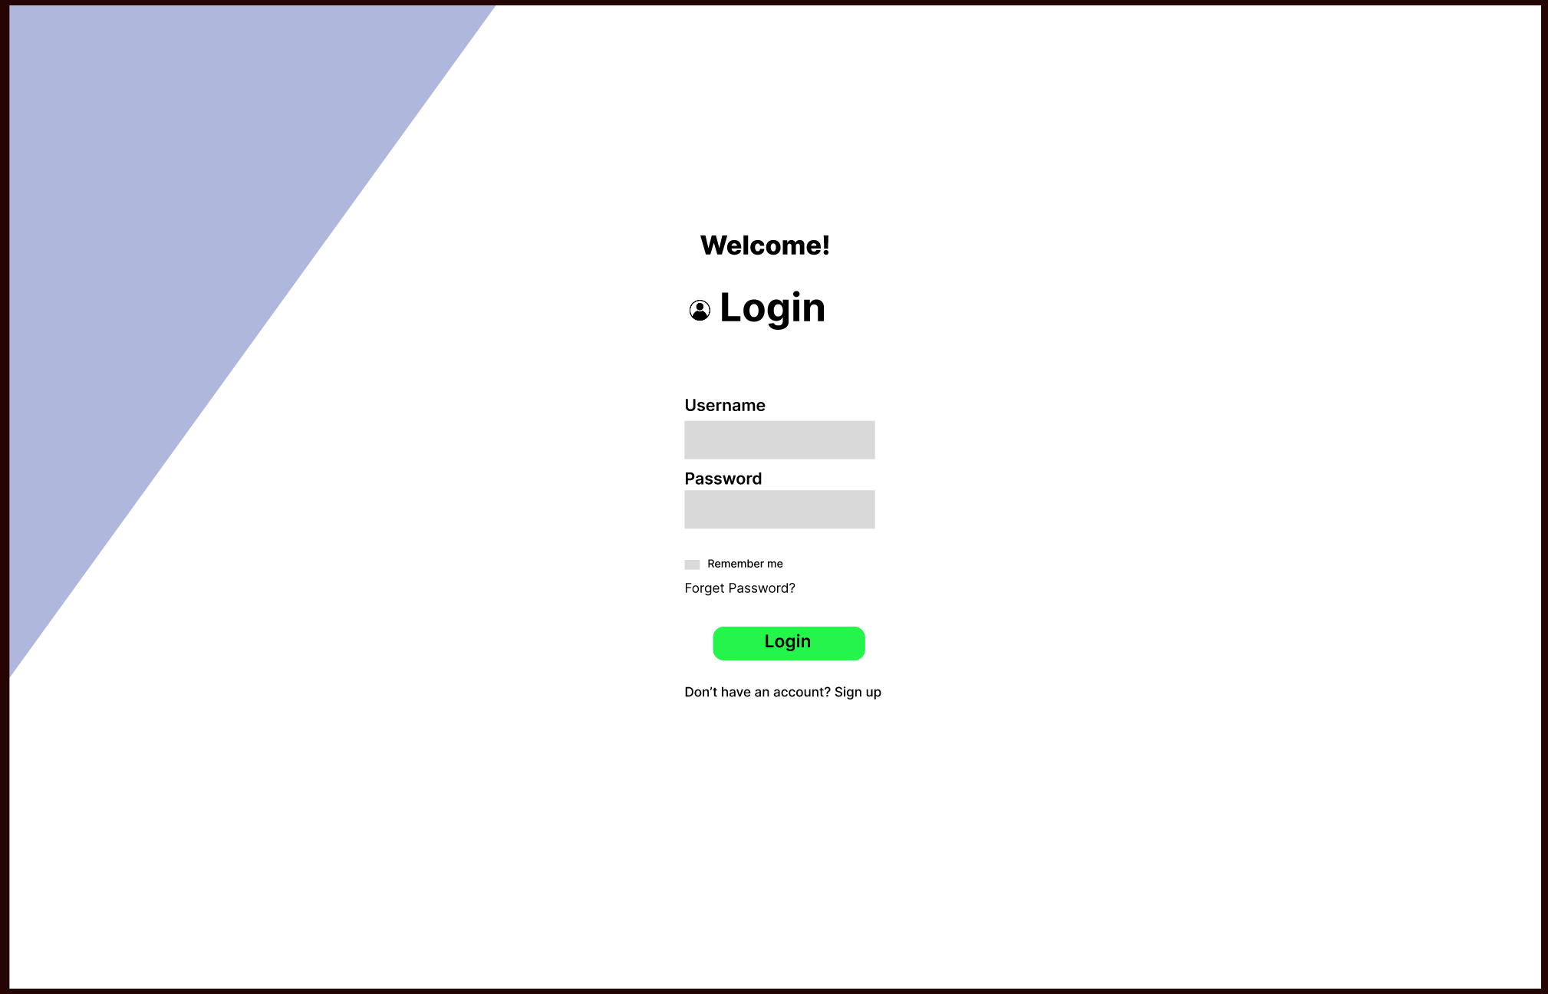

3.2.2. Signup page
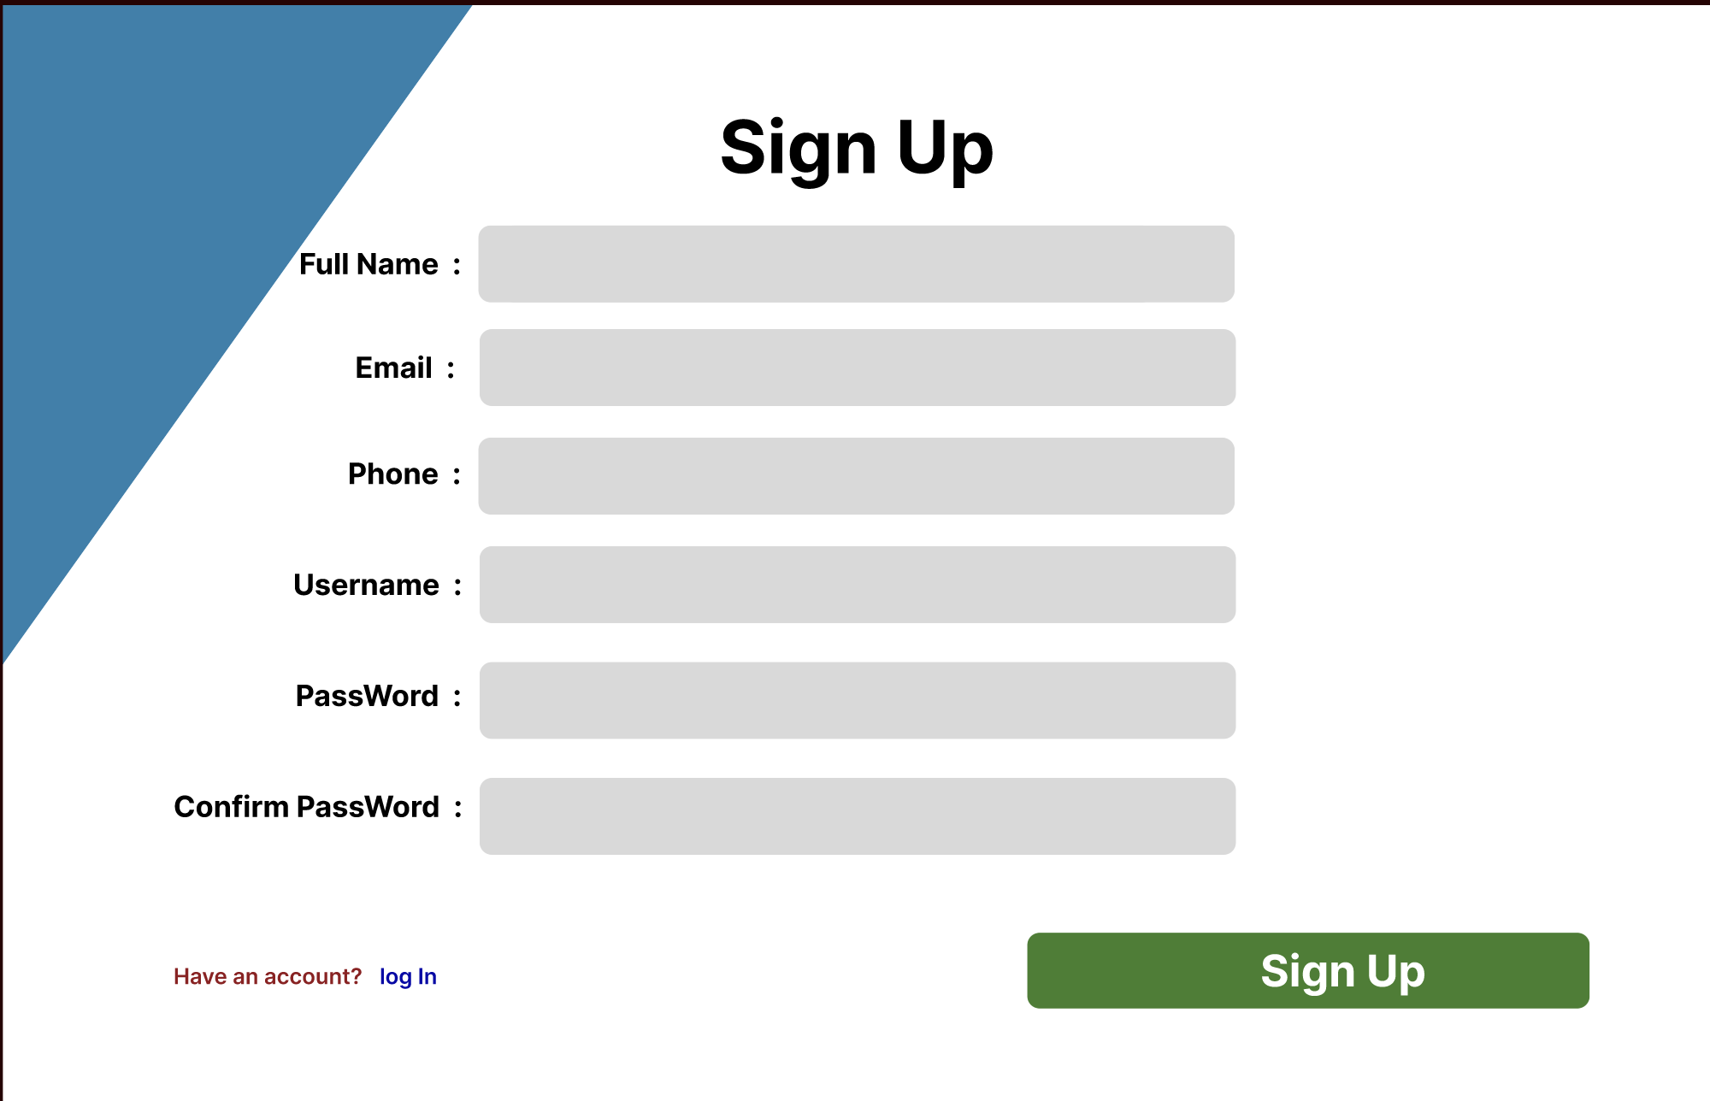
3.2.3. Admin Dash Board
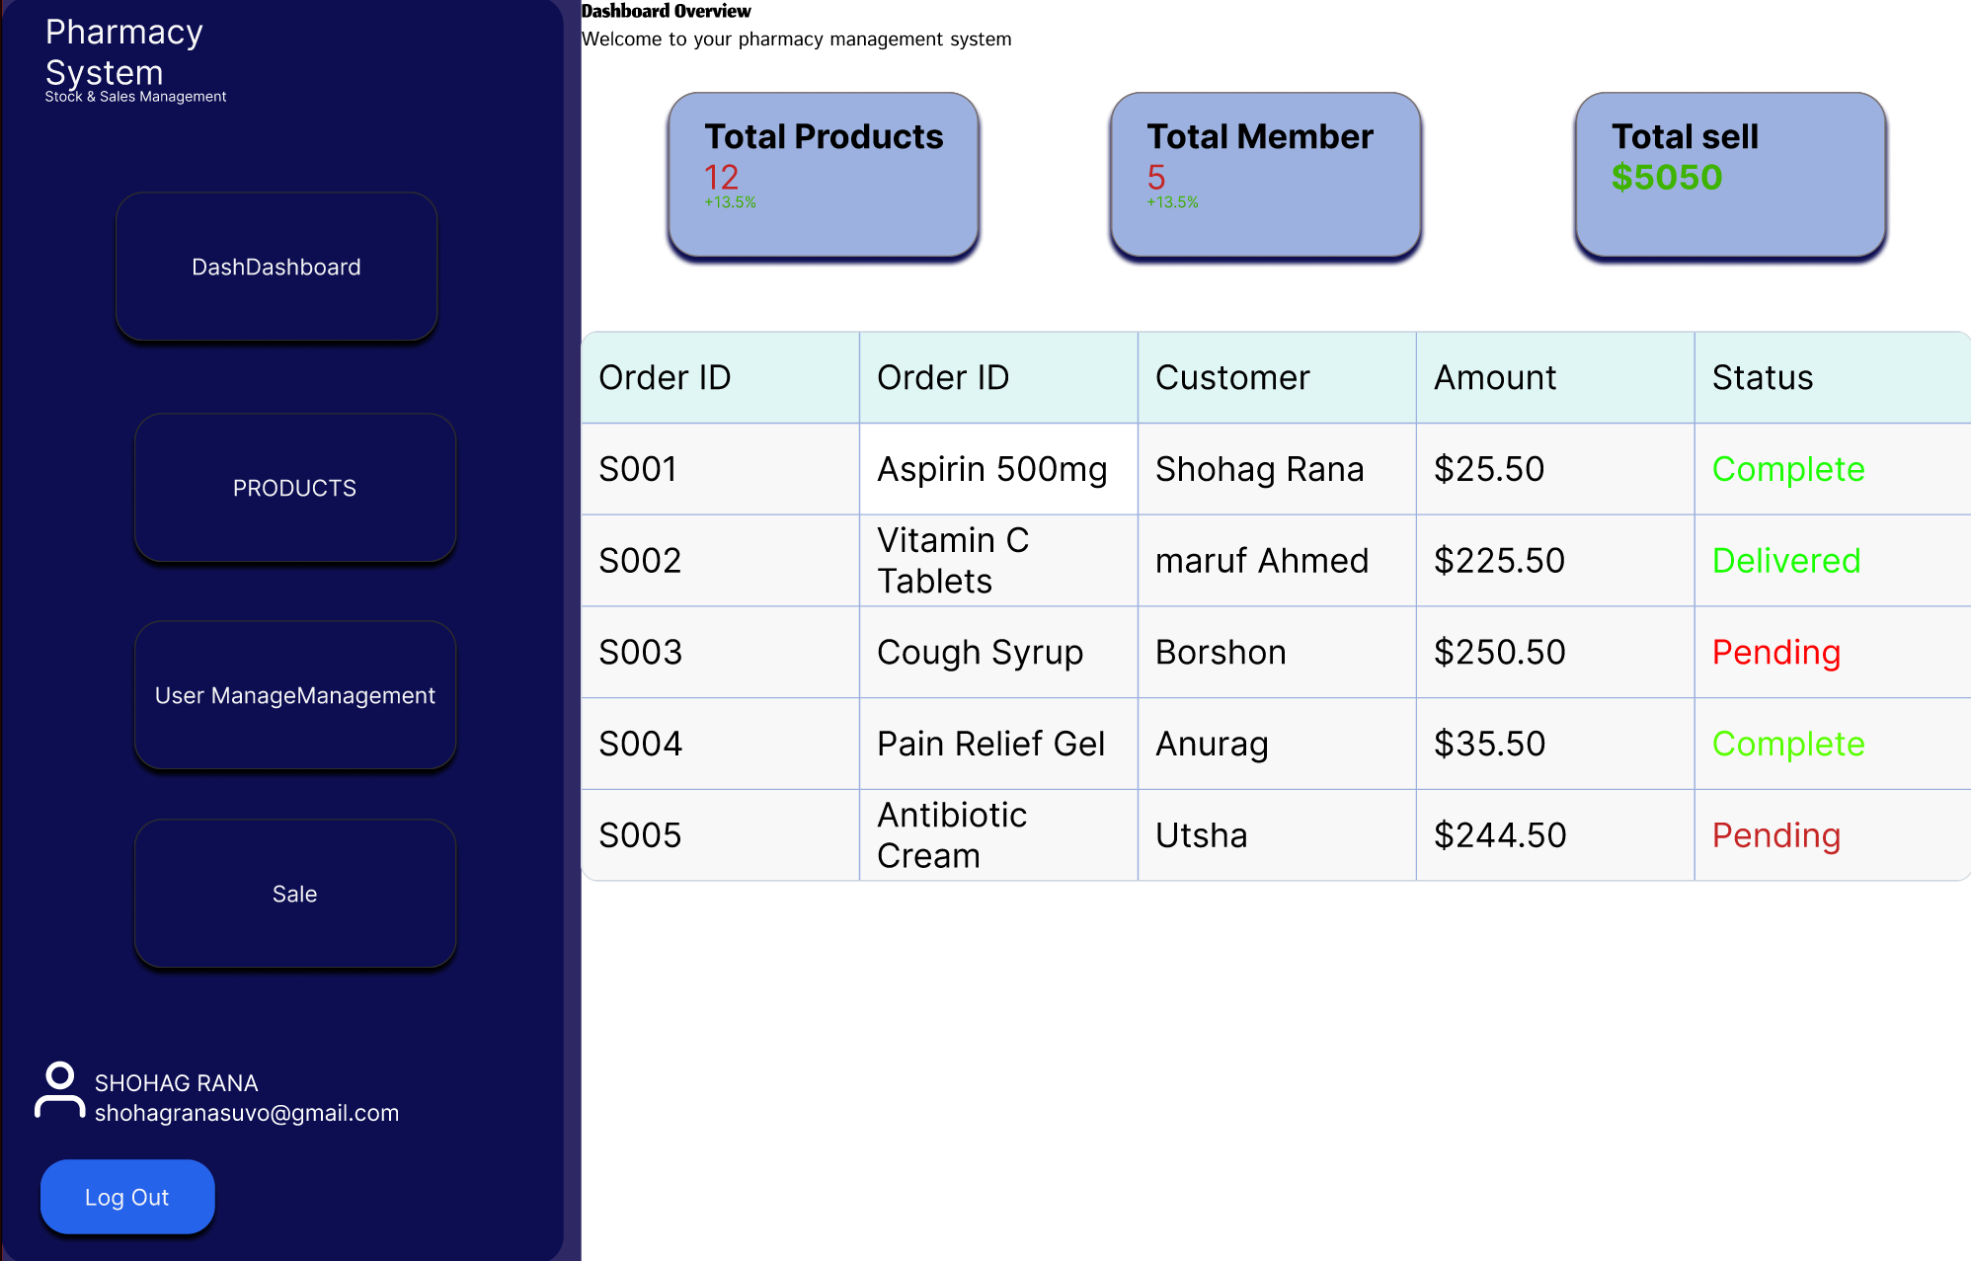
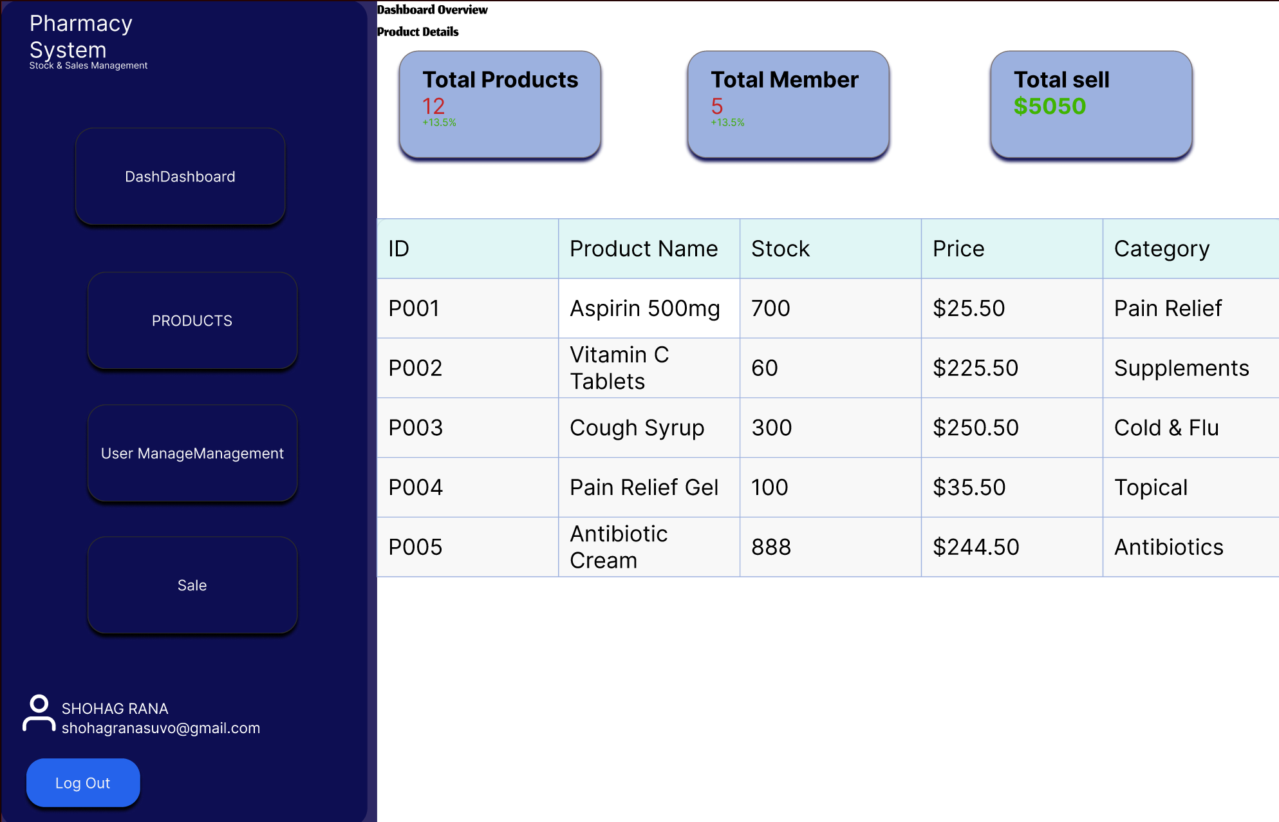
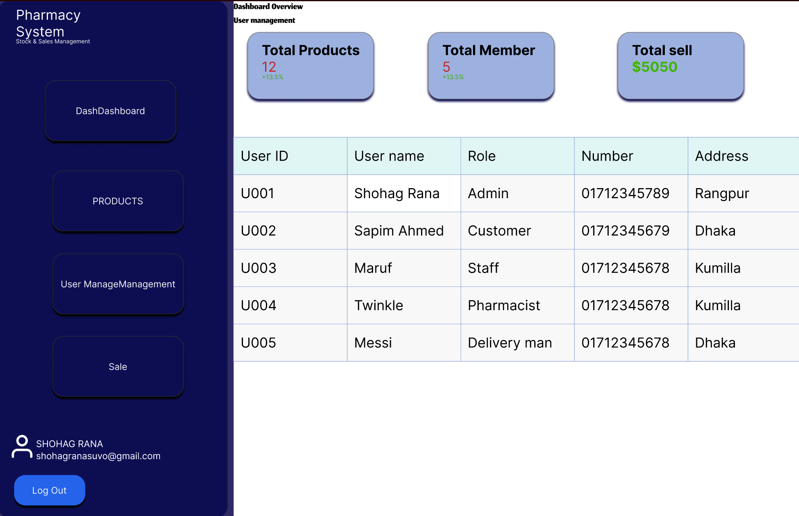
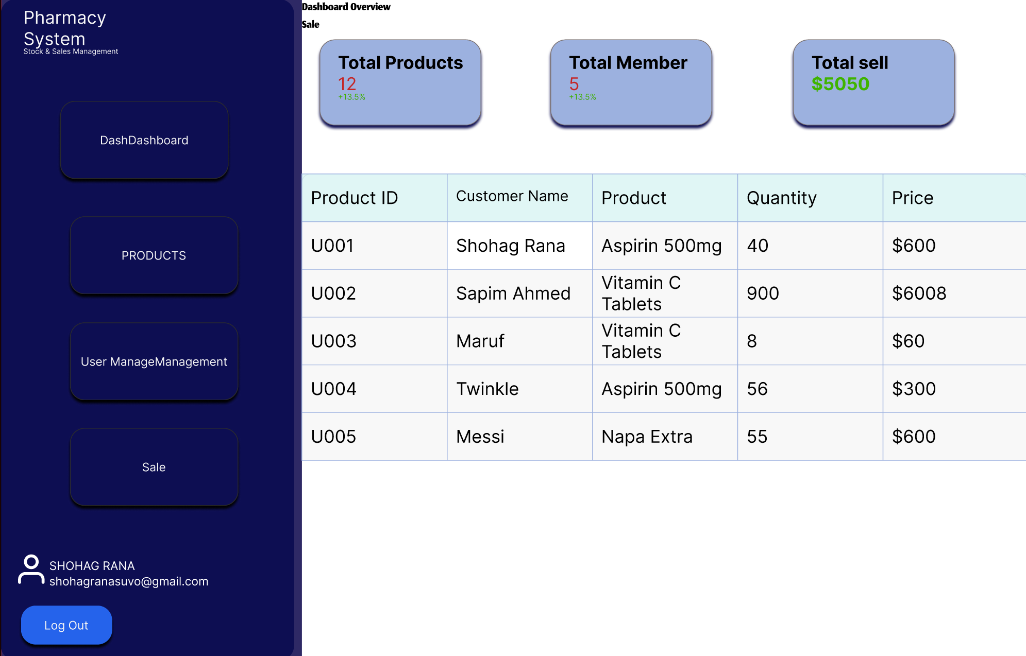
Link : https://www.figma.com/design/Nuef37naQOckEjInXvLxQd/Pharmacy-Stock-and-Sales-Management-System-Admin-dash-Board?node-id=0-1&t=iomxTIUdspiq6TuY-1

4.1. GIT WORKFLOW
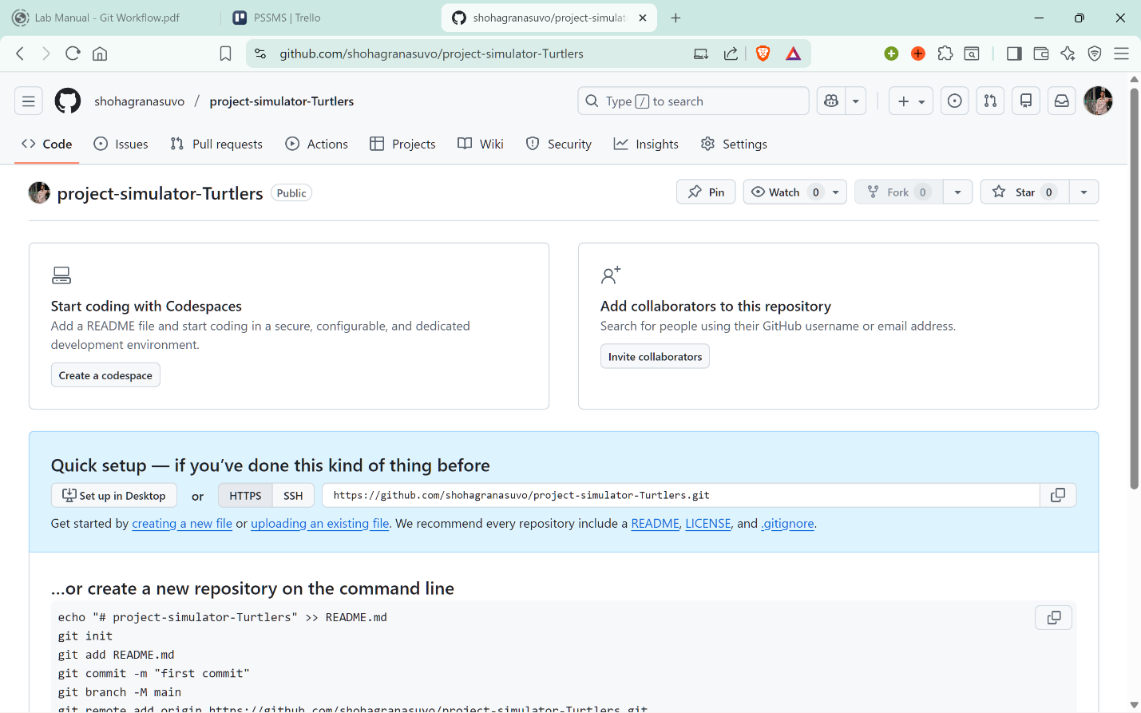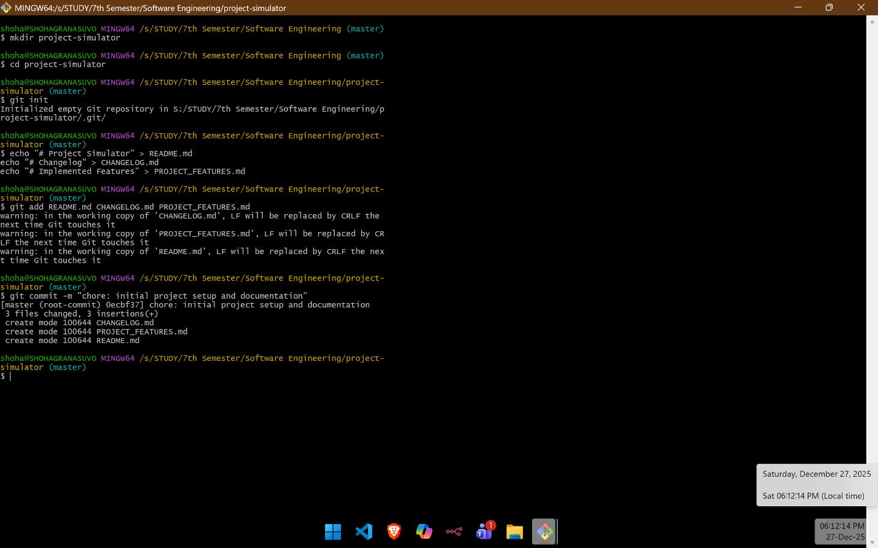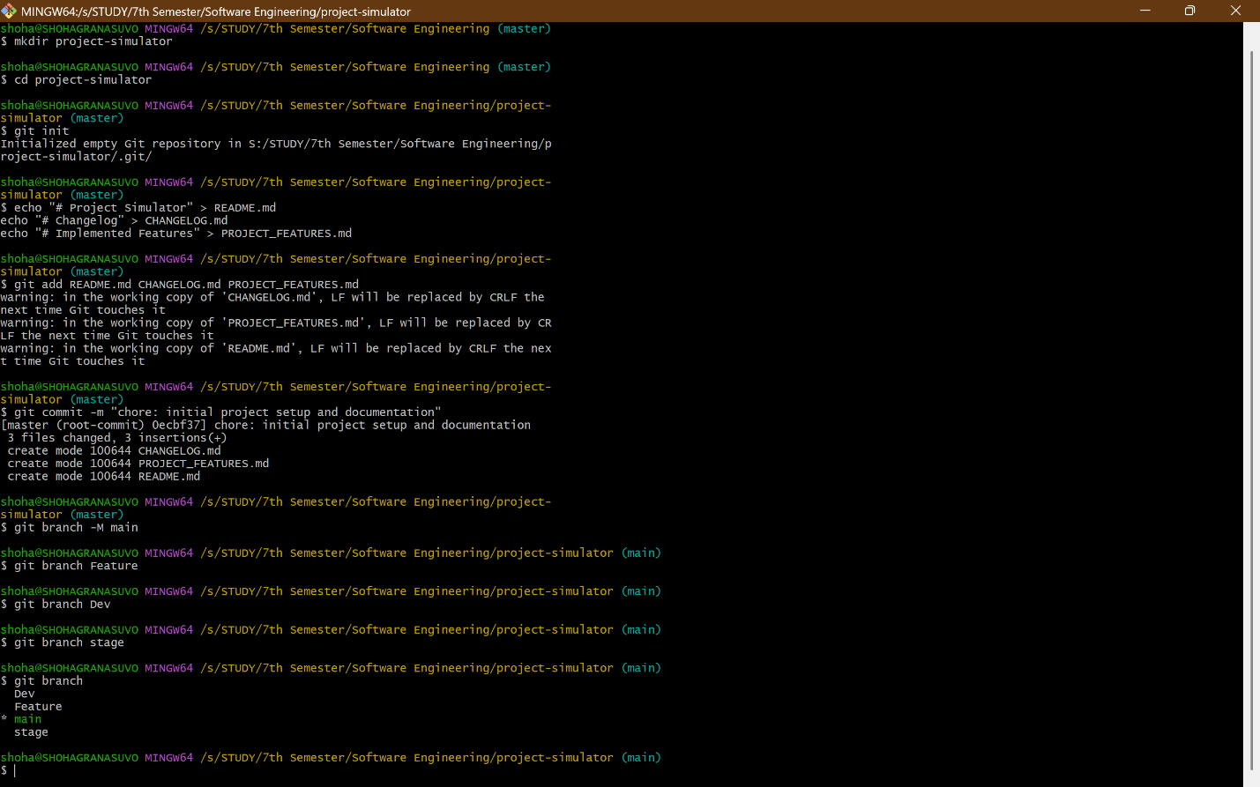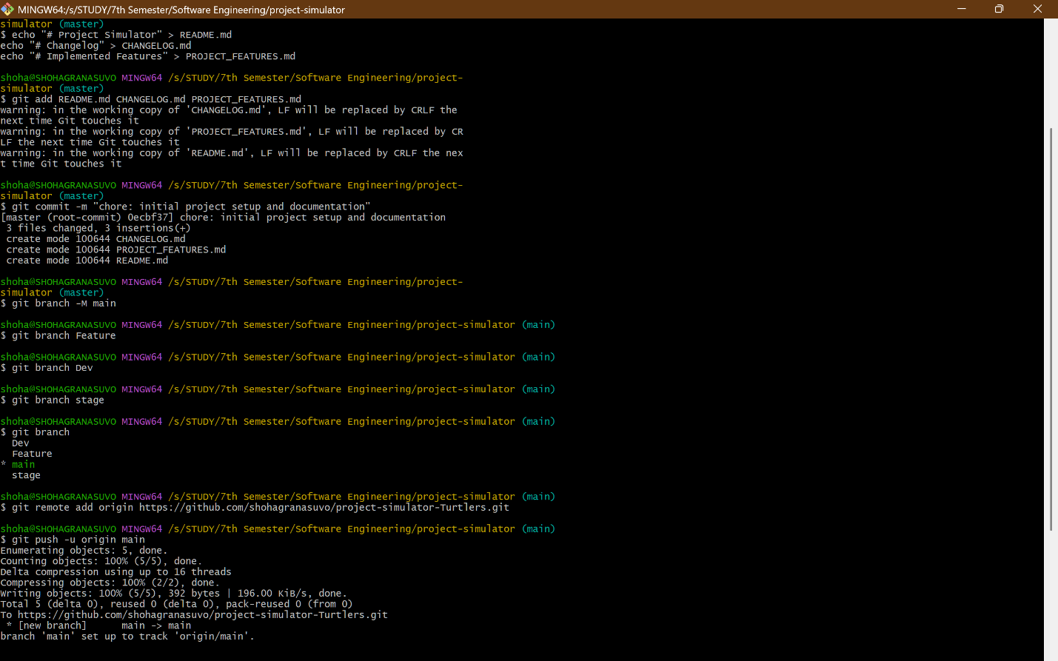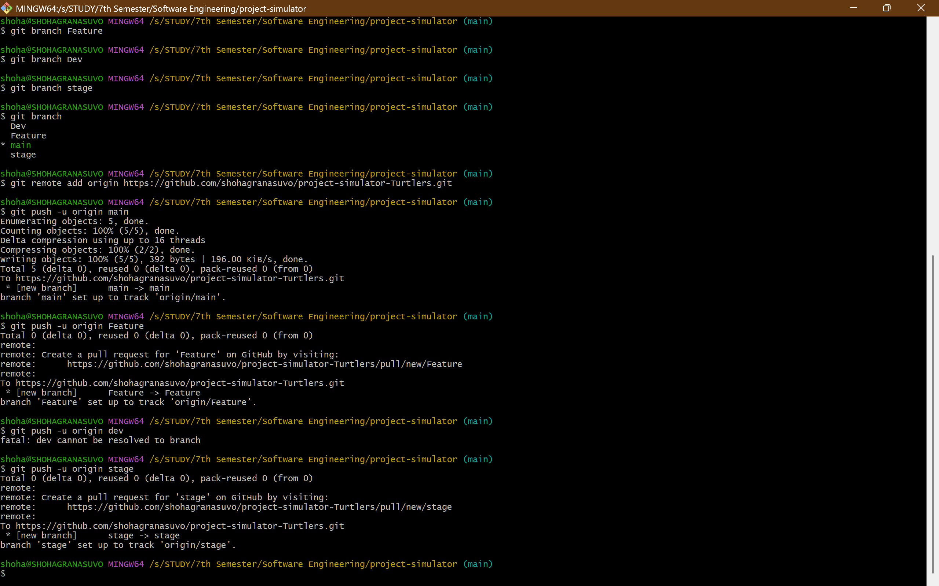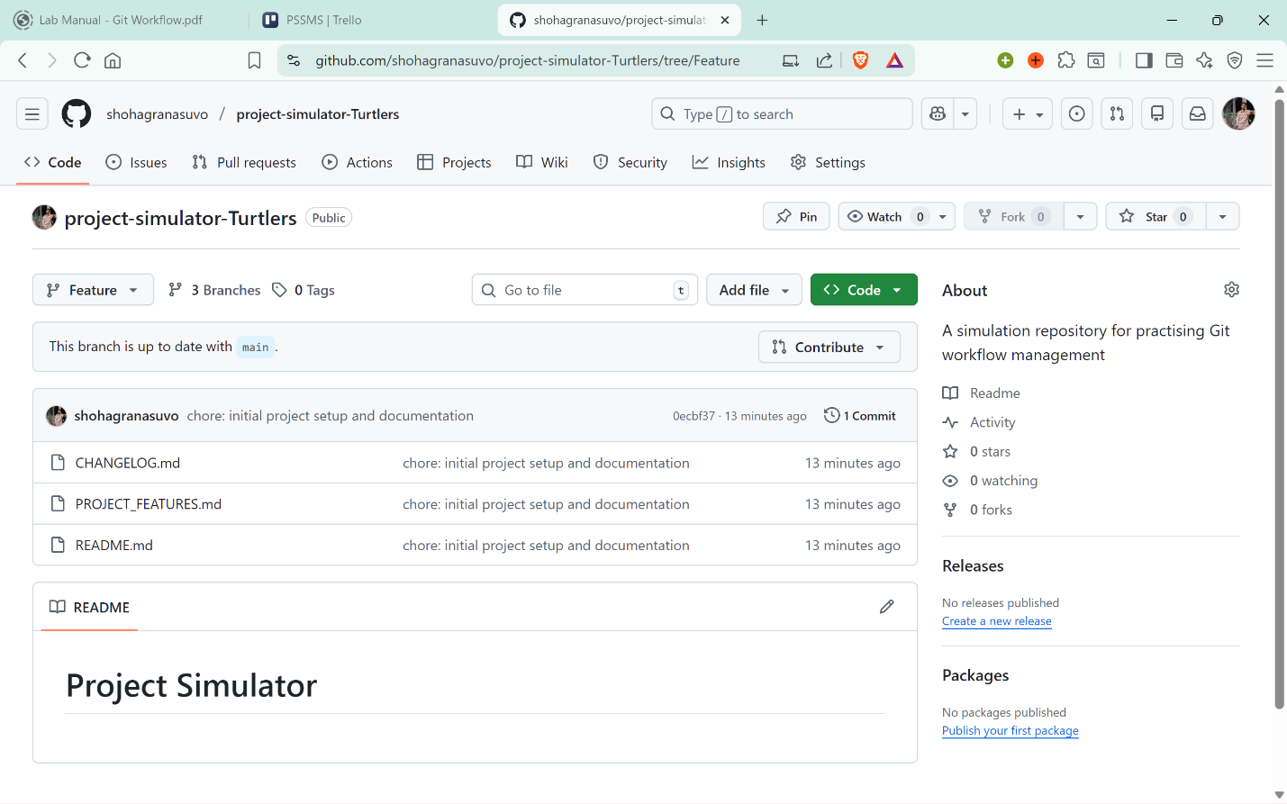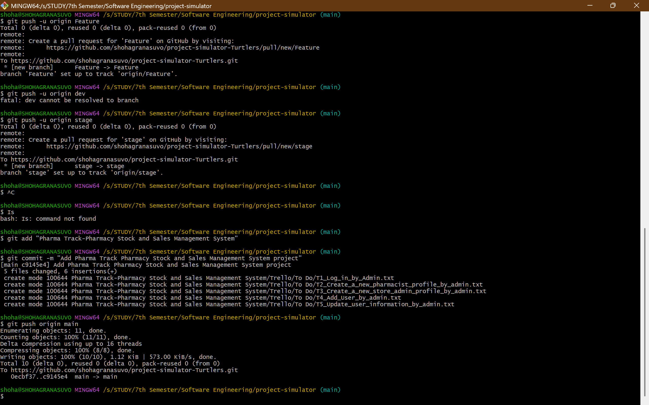

4.2.Clone Git Workflow:

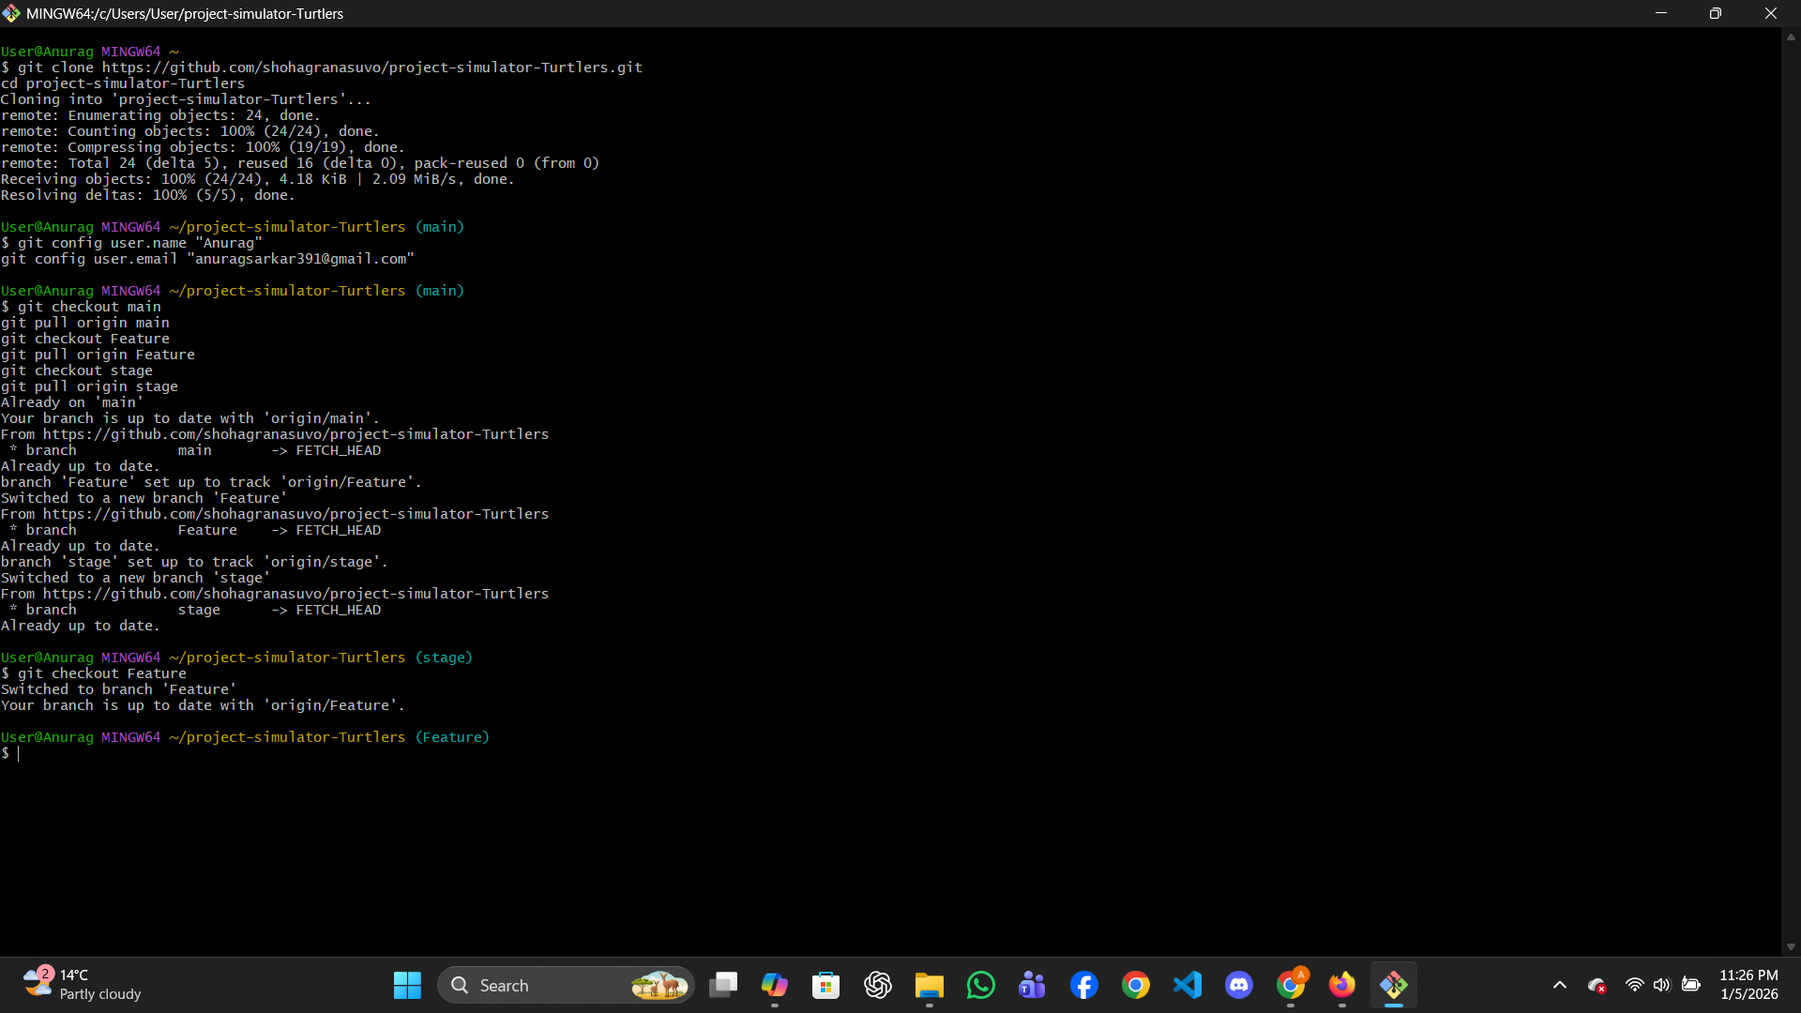

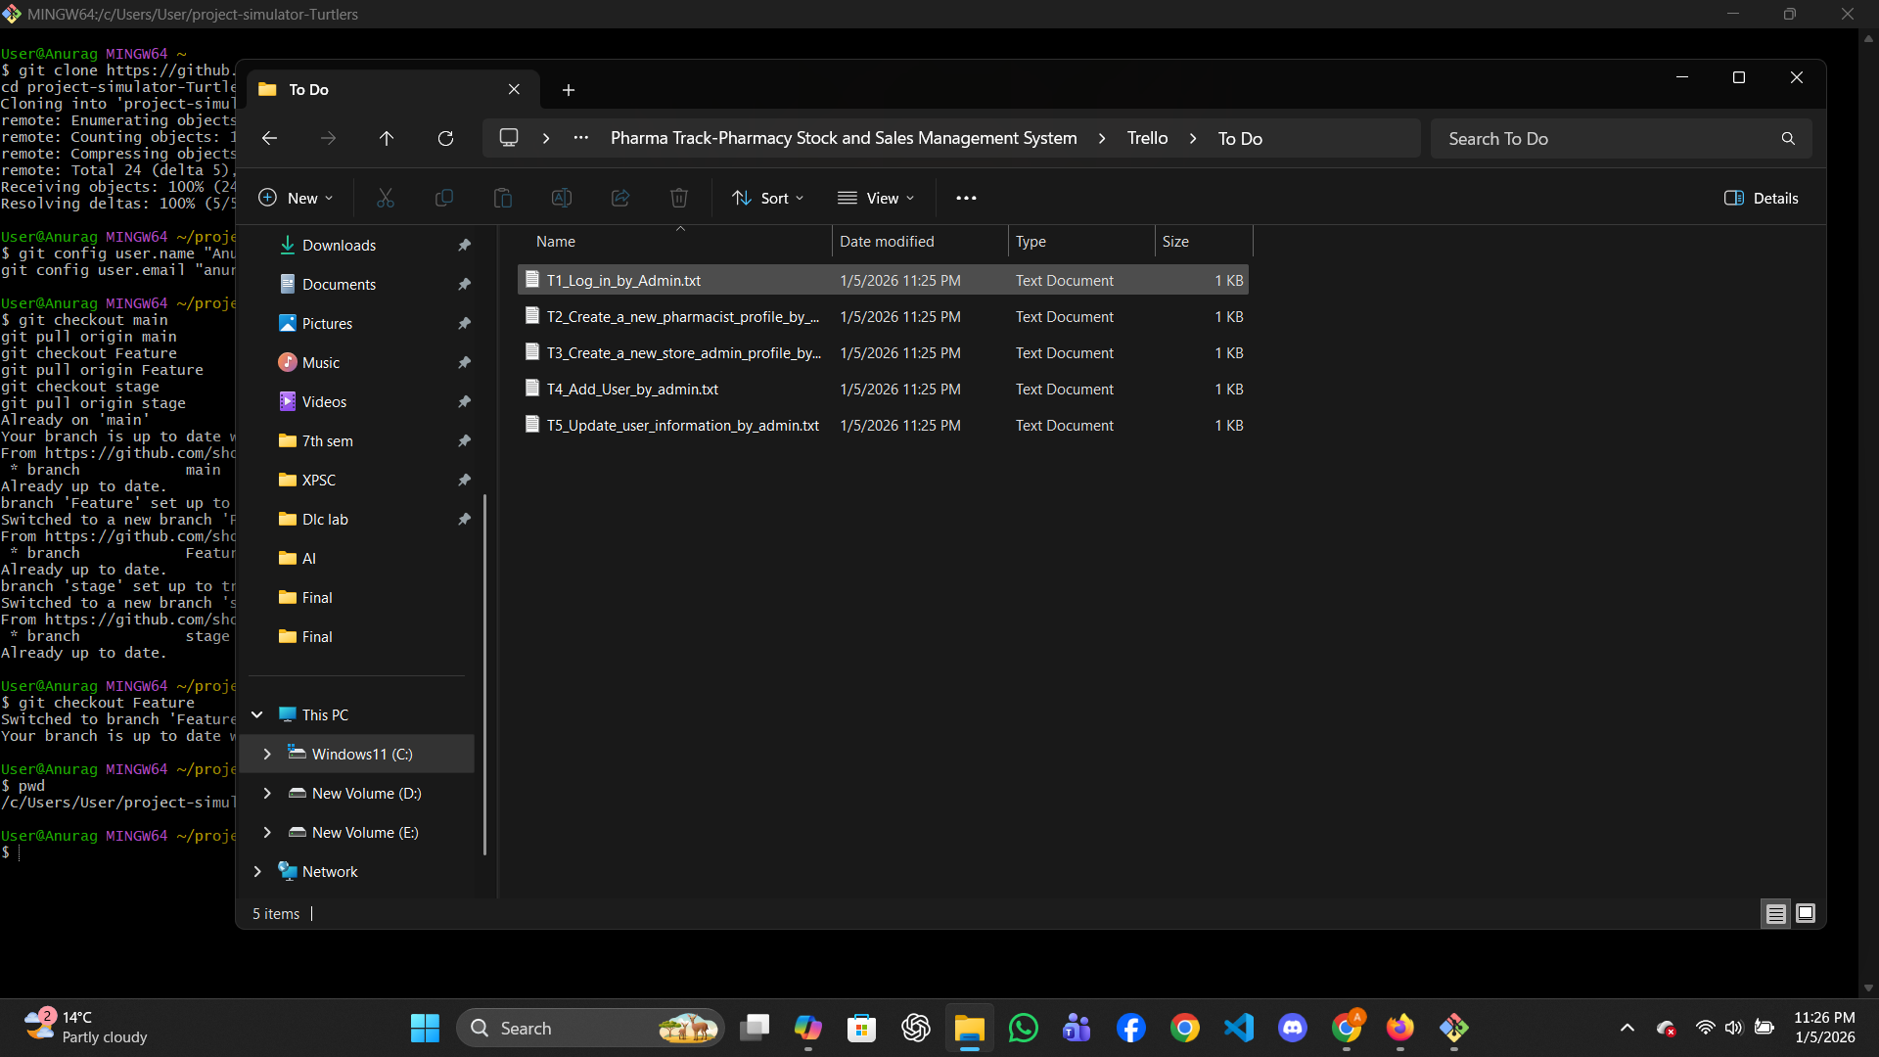

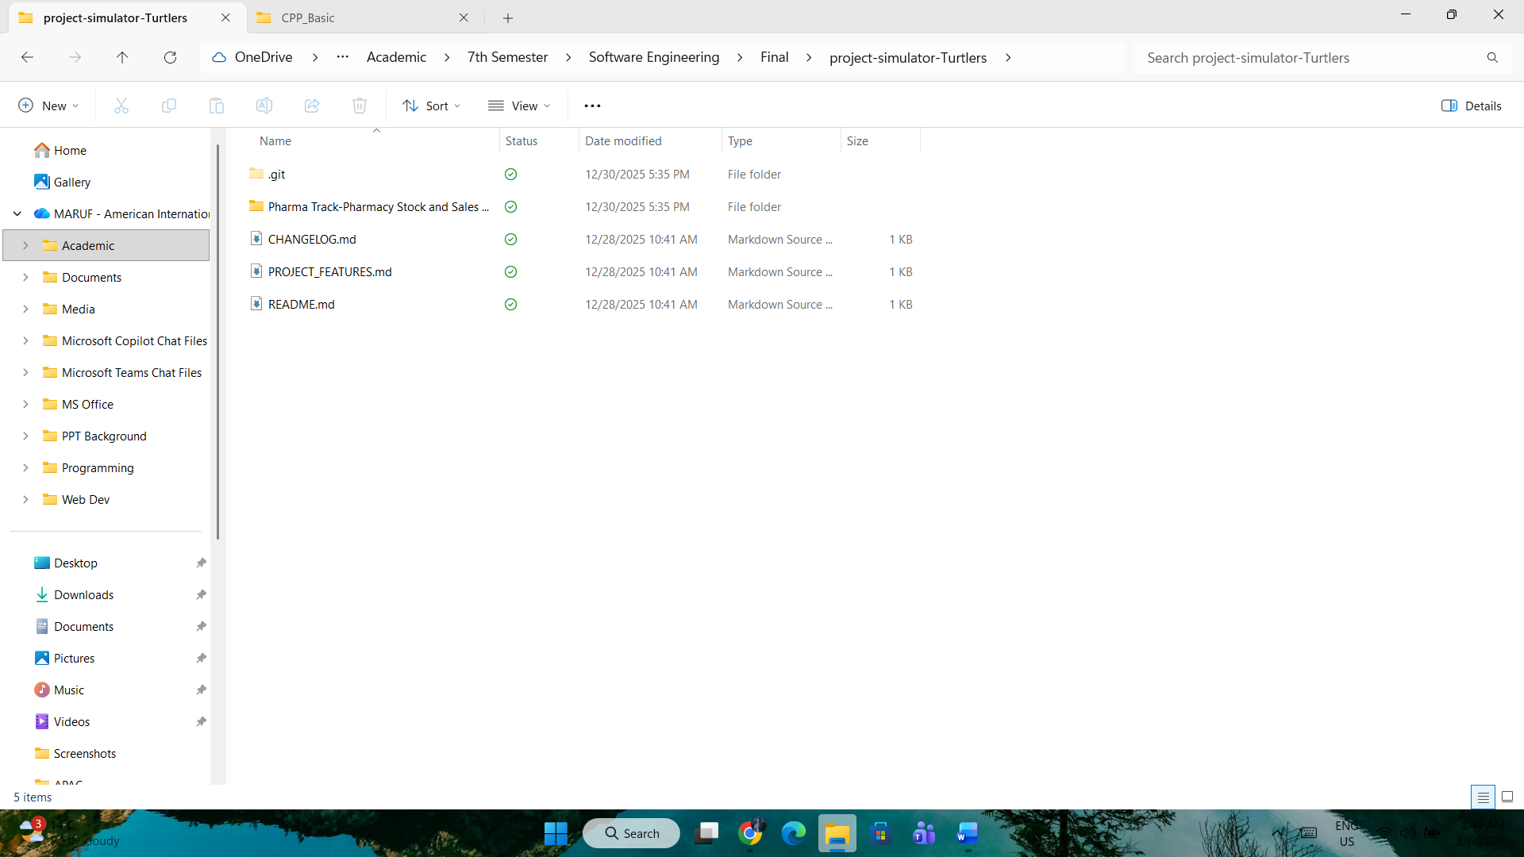

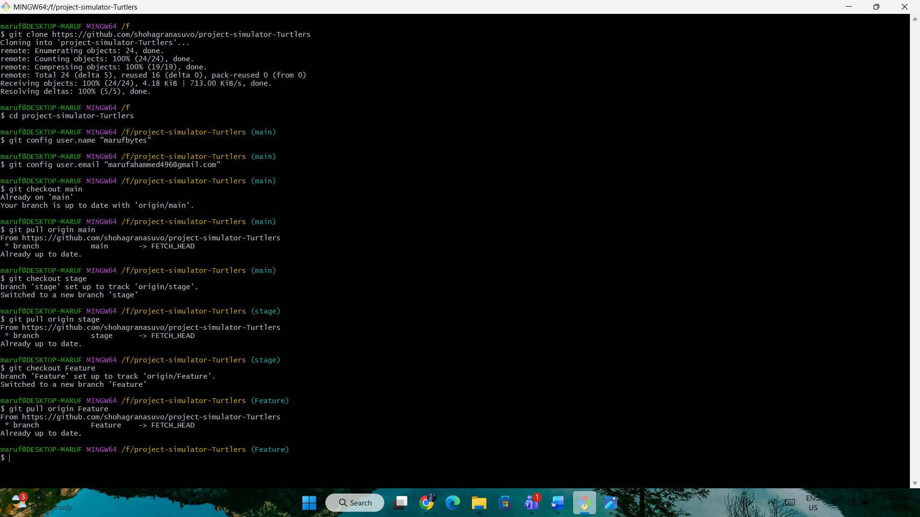
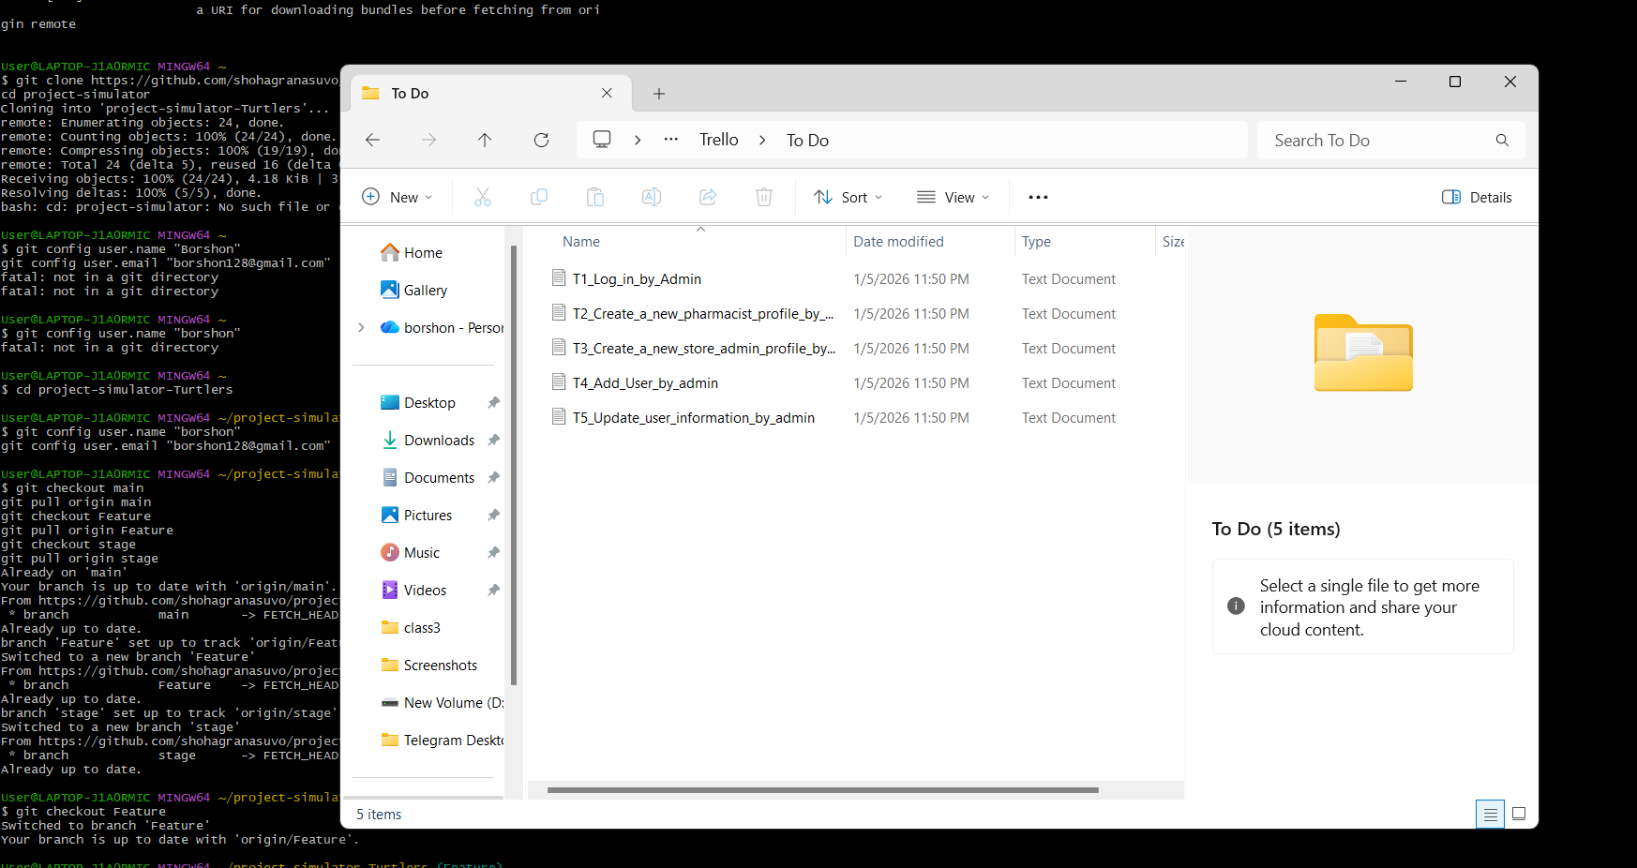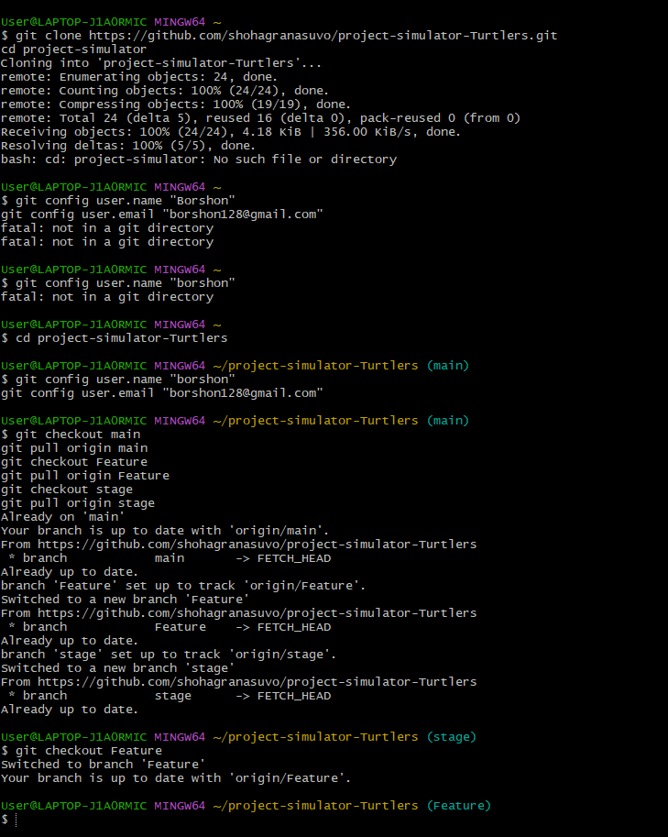

5. SOFTWARE TESTING
1.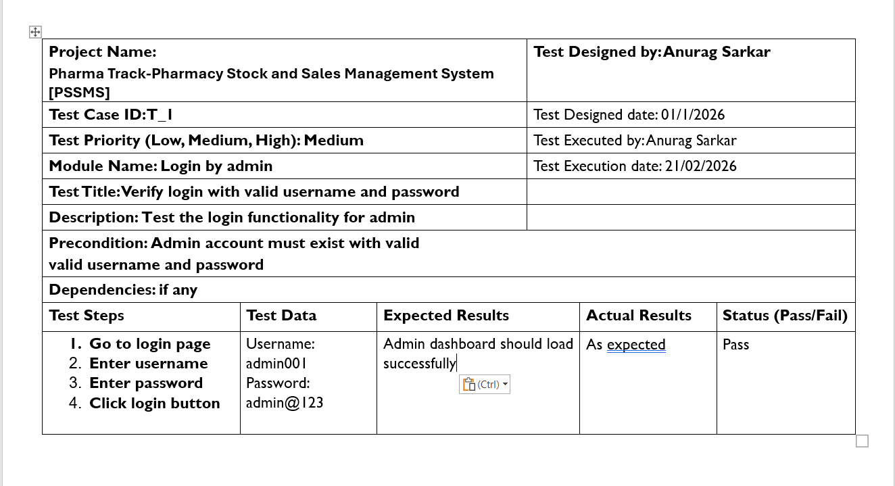2.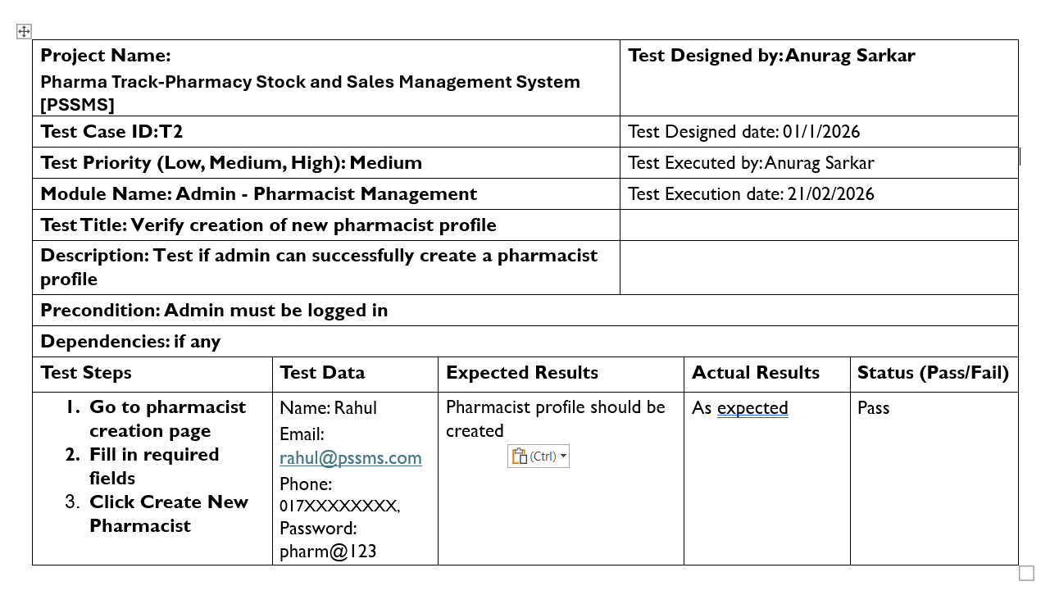
3.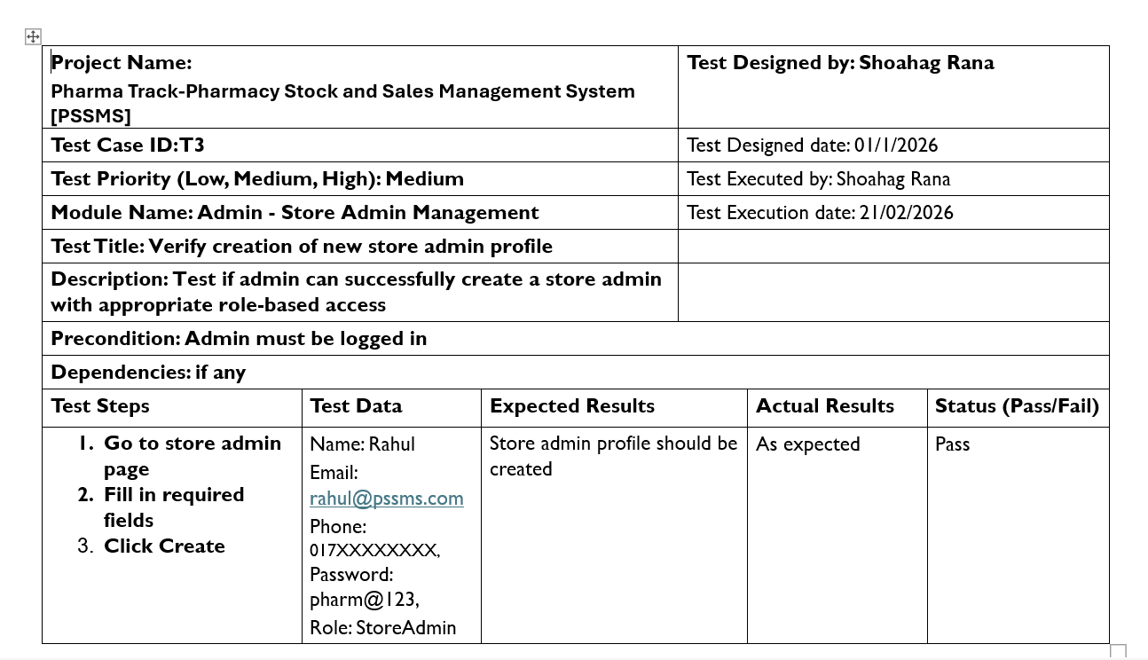4.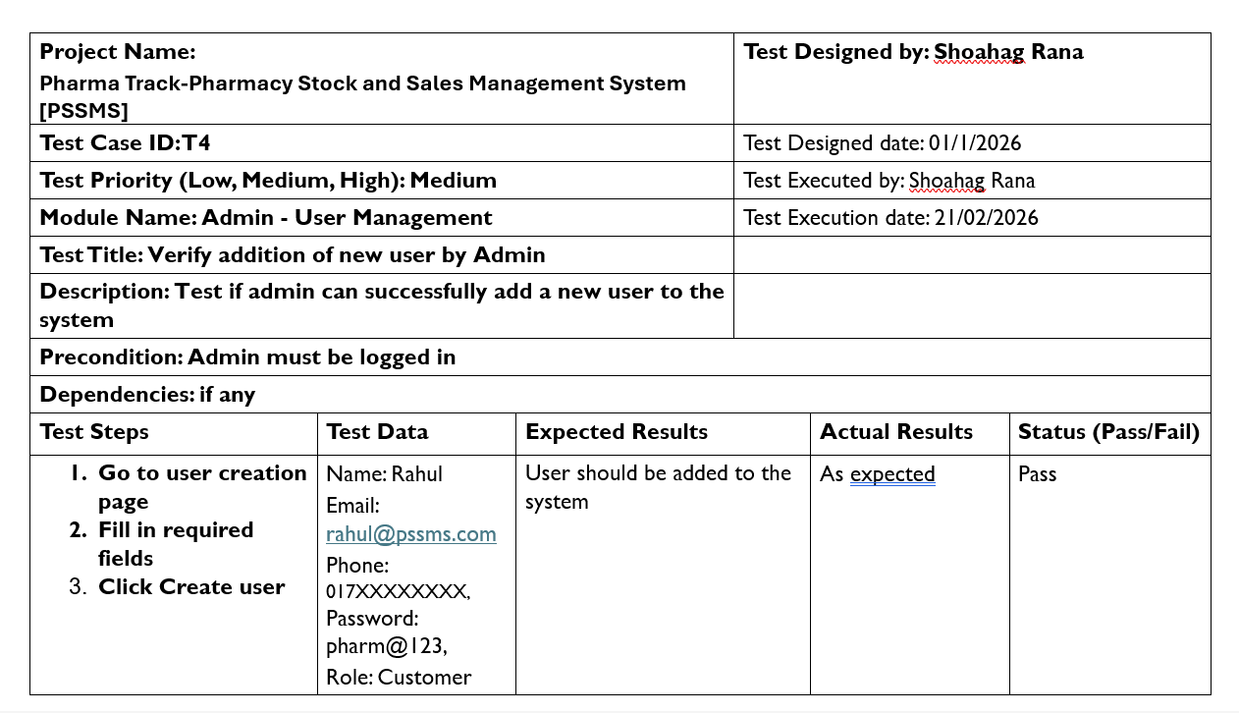

5.
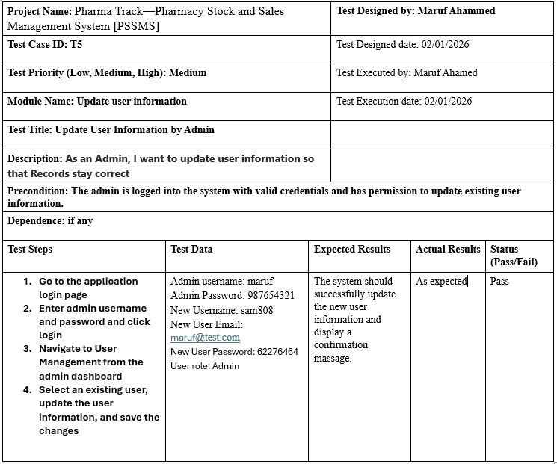

6.
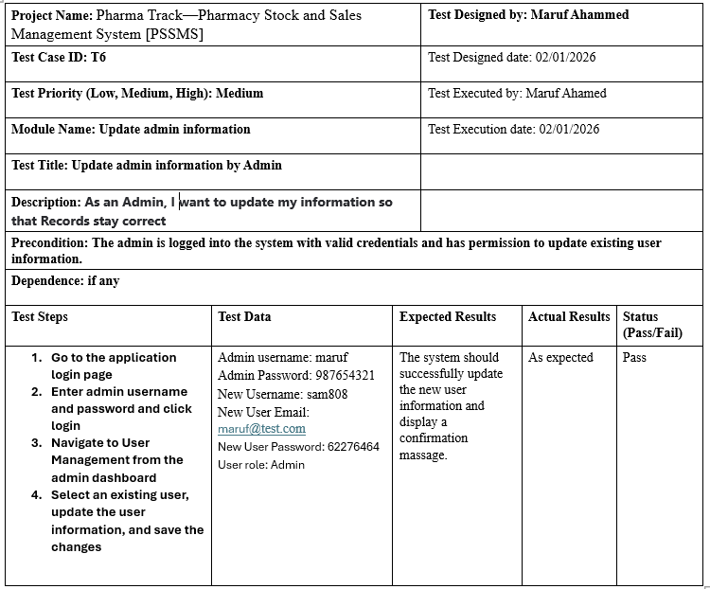

7.
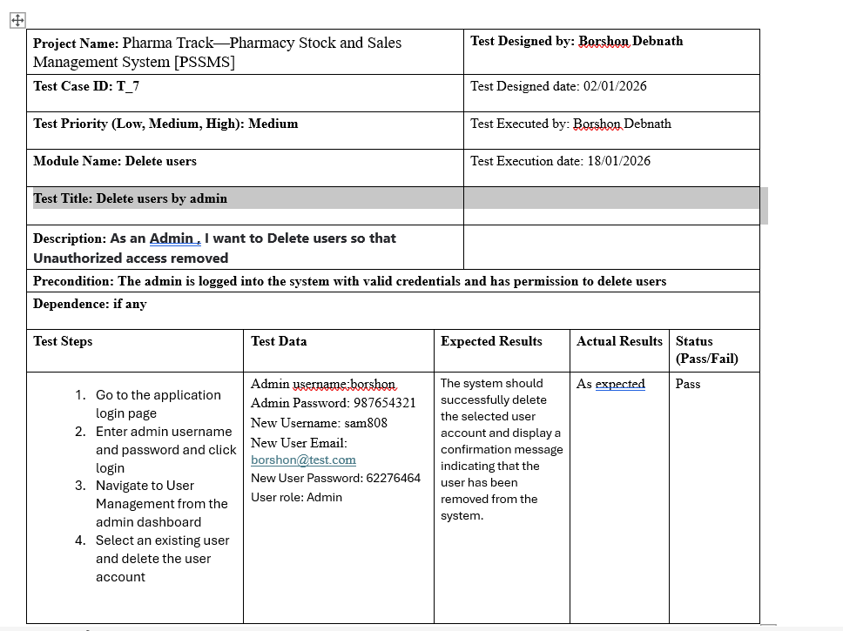
8.
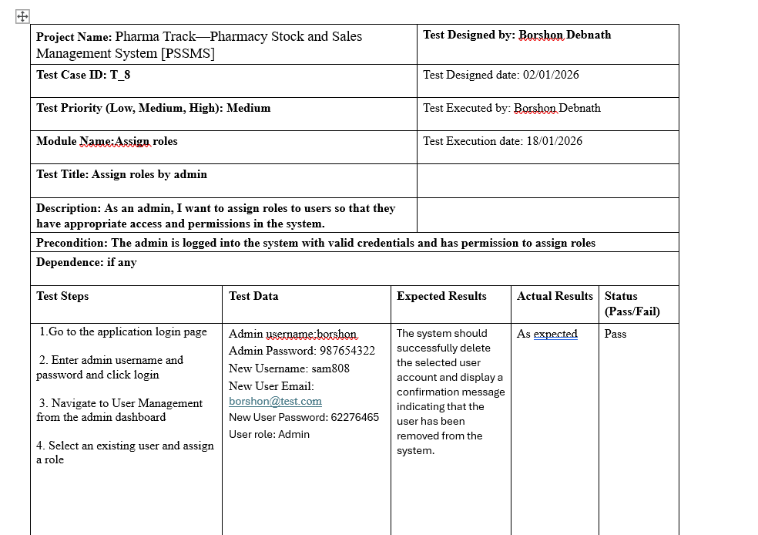

6. CONCLUSION
The Pharma Track – Pharmacy Stock and Sales Management System (PSSMS) was designed to address the limitations of traditional, manual pharmacy management by providing a modern, reliable, and automated solution. This project successfully integrates core pharmacy operations such as user management, inventory tracking, sales and billing, supplier coordination, and reporting into a single unified system. By clearly defining system requirements through a comprehensive SRS and requirements traceability matrix, the project ensures that all functional and non-functional requirements are properly addressed.

The selected software process model enables a structured and systematic development approach, ensuring smooth progression from requirement analysis to system design, implementation, testing, and documentation. The system design artifacts, including use case diagrams, class diagrams, and UI wireframes, provide a clear visualization of system behavior and user interactions. Version control and collaboration were effectively managed using Git workflow, allowing team members to work efficiently and track progress transparently.

Furthermore, software testing was planned using well-defined manual test cases to validate system functionality, usability, and reliability. These test cases help ensure error-free operations and improved system quality. Overall, PSSMS demonstrates how proper planning, structured development, and testing can produce a scalable and efficient pharmacy management system that enhances operational efficiency, accuracy, and decision-making in the modern digital pharmacy environment.

